Q1. 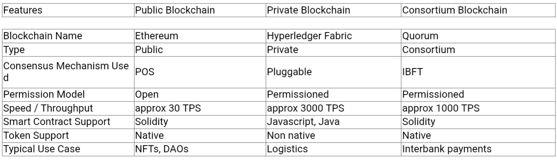

Q2.
Ethereum is a public, permissionless blockchain supporting smart contracts written in Solidity. It relies on a proof-of-stake consensus and is ideal for decentralized applications.

Hyperledger Fabric is a permissioned blockchain designed for enterprise use. It offers high throughput, pluggable consensus, and private channels for confidential data sharing. It supports in languages like Javascript and Java.

Quorum adds permissioned access, private transactions, and improved performance to ethereum capabilities. It uses consensus mechanisms like IBFT instead of POS.

For decentralized app: Ethereum because it is suitable for open, trustless environments with broad developer support.

For supply chain network among known partners: Hyperledger Fabric because it offers data privacy and efficient transaction handling.

For inter-bank financial application: Quorum because it provides Ethereum compatibility, and additional features.

